Deliverable 3: Technical Documentation
Project: Agentic RAG Customer Support Assistant
Engineer: Ruchitha
Company: Innomatics Research Labs (Internship Project)
1. Introduction
What is RAG?
Retrieval-Augmented Generation (RAG) is a framework that retrieves relevant documents from an external knowledge base and passes them to a Large Language Model (LLM) to generate a response. This ensures the AI remains grounded in factual data rather than relying on its training data alone.
Why It Is Needed
For ShopEase, a standard AI might hallucinate shipping times or refund rules. Our RAG system ensures that the AI only speaks from the provided knowledge_base.pdf, providing a reliable "Single Source of Truth."
2. System Architecture
The system is built using a modular architecture to ensure scalability and reliability.
- Ingestion: Raw PDF data is processed into 1000-character chunks.
- Vector Database: ChromaDB stores these chunks as high-dimensional vectors.
- Orchestration: LangGraph manages the state and decision-making flow.
3. Design Decisions
- Chunking Strategy: A 1000-character chunk size with 100-character overlap was chosen to ensure the LLM receives enough surrounding context to understand specific instructions without hitting token limits.
- Model Selection: Llama 3.3 via Groq was selected for its ultra-low latency, enabling a real-time conversational experience in the terminal.
- Embedding Model: The all-MiniLM-L6-v2 model provides an optimal balance between retrieval accuracy and computational efficiency for a local development environment.
The Vector RAG Pipeline
- This diagram visualizes the mathematical core of the system, divided into two distinct workflows:
- 1. Offline Embedding Pipeline (The Top Section)
- Knowledge Source: The system takes the knowledge_base.pdf and breaks it into Document Chunks (1000 characters each).
- Transformation: These chunks pass through the HuggingFace Embedding Model, which converts text into high-dimensional numerical vectors.
- Storage: These vectors are stored in the Vector Store (ChromaDB), organized spatially by their semantic meaning.
- 2. Online Query & Retrieval Pipeline (The Bottom Section)
- User Input: When a user submits a query, it is immediately converted into a Query Vector using the same embedding model.
- Mathematical Search: The system performs a Nearest Neighbor search in the vector space. It identifies the "closest" dots (data points) to the query's location.
- Context Generation: The Top-K Relevant Chunks are retrieved. These provide the LLM with the specific facts needed to answer the user accurately without hallucinating.

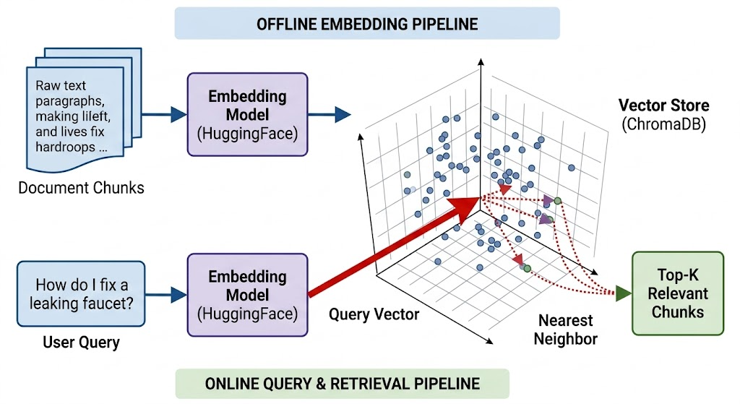
4. Workflow
The most critical part of this system is the Router. It protects the brand by preventing the AI from answering sensitive questions it isn't "confident" about.
- Keyword Guardrails: If the query contains "refund" or "manager," the system bypasses the AI and goes straight to a human agent.
- Confidence Guardrails: If the retriever finds fewer than 2 relevant chunks, the system flags "Low Confidence" and escalates.
"Unlike traditional AI chatbots that follow a linear path, this system implements an Agentic RAG architecture. As shown in the comparison below, our use of LangGraph allows the system to evaluate its own search results and make real-time routing decisions, providing a level of safety and accuracy that linear chains cannot achieve."

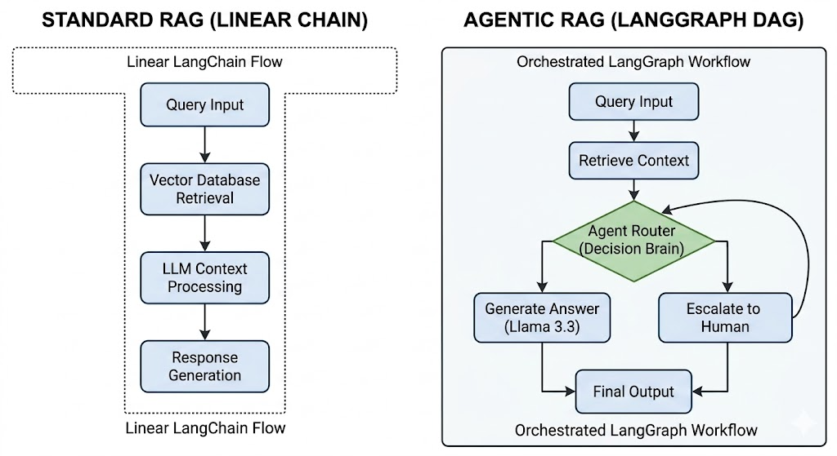
Figure 4.1: Comparison between Linear RAG and the implemented Agentic DAG workflow.

5.Conditional logic
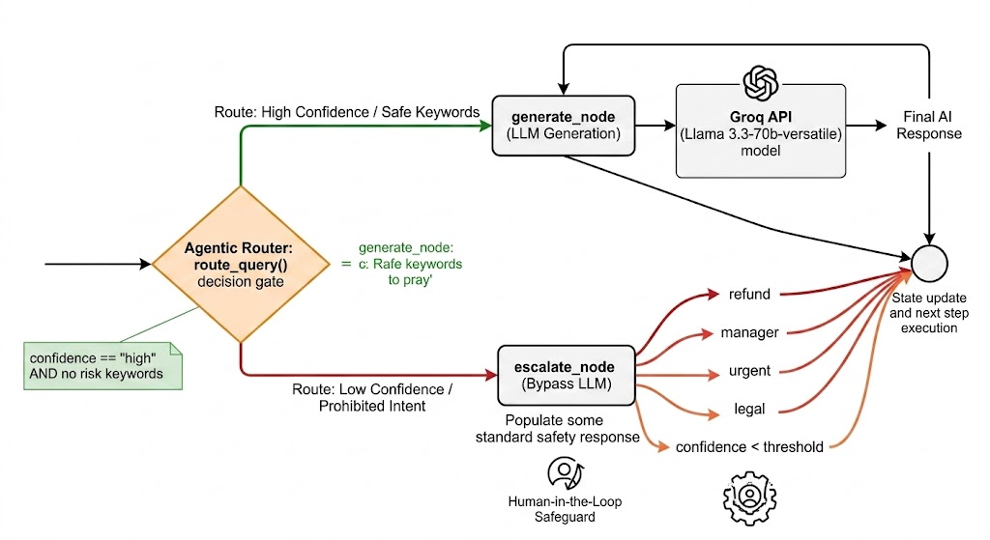

This diagram provides a granular look at the Decision Intelligence within the route_query() function. It illustrates how the system maintains operational safety and response accuracy.
1. The Agentic Router (Decision Gate)
The router acts as the system's "Governor." Before any text is generated by the LLM, the router performs a high-speed evaluation of the current GraphState.
2. Path A: Safe Generation (Green Path)
- Criteria: This path is only selected if the Confidence Score is "high" (meaning relevant data was found in the PDF) AND no Prohibited Keywords were detected.
- Result: The system triggers the generate_node, passing the validated context to the Groq API (Llama 3.3) to produce a helpful customer response.
3. Path B: Risk Mitigation & Escalation (Red Path)
- The Logic: If the system detects specific high-risk intents or a lack of supporting information, it immediately halts AI generation.
- Trigger Categories:
  - Policy Risks: Detection of keywords like "refund", "manager", "urgent", or "legal".
  - Knowledge Gaps: If the retrieval confidence is below the threshold (confidence < threshold), the system admits it doesn't know the answer.
- Human-in-the-Loop (HITL): The system routes to escalate_node, which populates a standard safety response. This ensures that the user is redirected to a human agent rather than receiving a potentially incorrect or unauthorized AI answer.
6. Challenges & Trade-offs
- Path Management: We faced issues with loading environment variables from sub-directories. This was solved by using dynamic pathing (os.path.join) to locate the .env file regardless of where the script is executed.
- Retriever Performance: Initially, some queries returned "low confidence" incorrectly. We adjusted the chunk_overlap to ensure important sentences weren't being cut off, which improved retrieval success rates.
7. Future Enhancements
- Memory Integration: Adding a "Chat History" node so the agent remembers previous parts of the conversation.
- Web Interface: Moving from a CLI terminal to a Streamlit dashboard for a professional user experience.

